Network application services

Common network application services

What are the most common internet services that you use on a regular basis?

For most people, the list includes services such as internet seaches, social media sites, video and audio streaming, on-line shopping sites, email, and messaging.

Each of these services relies on protocols from the TCP/IP protocol suite to reliably communicate the information between the clients and the servers.

Some of the most common servers that provide these services are shown in the figure

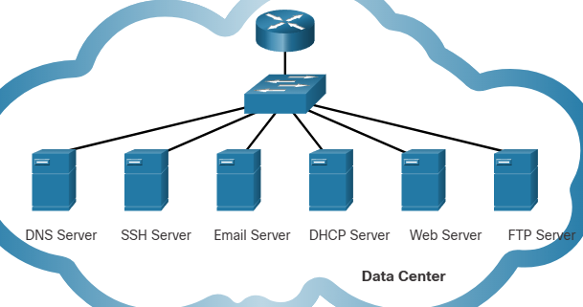

domain name system (DNS)

- **resolves internet names to IP addresses**

secure shell (SSH)

- used to **provide remote access to servers and networking devices**

simple mail transfer protocol (SMTP)

- **sends email msg and attachments from clients to servers and from srvs to other email srvs**

Post office protocol (POP)

- **used by email clients to retrieve email and attachments from a remote server**

Internet message access protocol (IMAP)

- **used by email clients to retrieve email and attachments from a remote server**

Dynamic host configuration protocol (DHCP)

- **used to automatically config devices with IP addressing and other necessary info to enable them to communicate over the internet**

Hypertext transfer protocol (HTTP)

- **used by web browsers to request web pages and web servers to transfers the files that make up web pages of the world wide web**

File transfer protocol

- **used for interactive file transfer between systems**